PRELIMINARY ANALYSIS REPORT
Service Provider Survey: Language Barriers in Refugee Services
Uganda | Data collected 22–30 July 2026
Updated KoboToolbox export: 1 August 2026
Draft prepared from the cleaned and harmonised service-provider dataset
Research Code Academy – Working Group 6
Preliminary findings; not for population-level generalisation

Executive Summary
This report presents a preliminary descriptive analysis of six service-provider responses to the survey on language barriers in refugee services. The analysis focuses on communication challenges, the availability and use of interpreters, effects within health and legal protection services, current communication strategies, digital-tool readiness, and priority support needs. Because the sample is very small, the results identify experiences and possible patterns but cannot represent all refugee-service providers in Uganda.
Key message
Language-discordant interactions were common, professional interpreter availability was uneven, and informal interpretation was routinely used. Respondents identified professional interpreters, formal training, bilingual staff, and better translation technology as complementary priorities rather than a single stand-alone solution.

- All six respondents had given consent, were aged 18 or older, and had unique submission identifiers. The export contained two form versions, which were harmonised before analysis.
- Four of six respondents worked in other refugee-hosting areas in Uganda and two worked in Bidibidi. The sample included two legal aid/protection officers, two other frontline humanitarian personnel, one social worker, and one healthcare worker.
- All respondents interacted with clients whose primary language differed from theirs at least sometimes; four did so often or always.
- Three respondents rated professional interpreters as never or rarely available, while all six relied on informal interpreters at least sometimes. Three relied on them frequently or always.
- Four respondents had not received formal training on working with language-discordant clients.
- Bilingual staff were the most frequently used and most highly rated communication strategy. Family or community members and printed multilingual materials received the lowest average reliability ratings.
- Poor connectivity and lack of support for local languages were each reported by four respondents. Staff training and better internet access were the two most frequently selected forms of support for digital tools.
- Five respondents were willing to pilot a free digital communication tool, but preferences were evenly divided among an AI chatbot, a real-time translation app, and a preference for human interpreters.
- More professional interpreters received the highest weighted priority score, followed by formal training.

1. Background and Purpose
Language differences can affect how refugees understand information, explain their needs, provide informed consent, follow procedures, and access services. The service-provider survey was designed to document how frontline personnel experience these barriers and how they currently respond to them. It also explored the perceived reliability of communication strategies, institutional support, and the potential role of digital translation or interpretation tools.
This preliminary report addresses four broad areas aligned with the questionnaire: general communication challenges; health-service delivery; legal and protection-service delivery; and communication strategies and tools. Structural and systemic barriers, including training, technology, internet access, and organisational support, are analysed across these areas.

2. Methodology

2.1 Data source and study sample
The analysis used the updated KoboToolbox exports generated on 1 August 2026. Six service providers submitted responses between 22 and 30 July 2026. The dataset included respondents working in Bidibidi and other refugee-hosting areas in Uganda. Results are reported in aggregate, using anonymous respondent identifiers.

2.2 Data cleaning and harmonisation
Two versions of the questionnaire were present in the export. As a result, several logically identical questions were stored in separate columns or under different technical headers. Before analysis, the two versions were harmonised by combining duplicate variables, standardising ordinal response labels, and merging select-multiple options across versions. Consent, age eligibility, submission identifiers, timestamps, and duplicate UUIDs were also checked.
All six submissions met the consent and age criteria, and no duplicate UUIDs were identified. Completion time ranged from 2.8 to 29.7 minutes, with a median of 13.6 minutes. No response was excluded solely on the basis of completion time because the retained records contained eligible and analysable responses.

2.3 Analysis approach
The analysis was descriptive. Counts and percentages were calculated for categorical questions, using the number of valid responses to each question as the denominator. For multiple-response questions, percentages can total more than 100% because respondents could select more than one option. Communication strategies were summarised with mean frequency scores from 0 (never) to 4 (always) and mean reliability scores from 1 (not at all reliable) to 5 (very reliable). Ranked priorities were weighted using three points for first choice, two for second choice, and one for third choice.
Interpretation rule
Counts should be read before percentages. With n = 6, one respondent represents 16.7 percentage points. Sector-specific health findings are based on one respondent and legal findings on two respondents.

3. Results

3.1 Respondent profile
Characteristic | Category | Count | Percent
Work location | Other refugee-hosting area in Uganda | 4 | 66.7%
 | Uganda, Bidibidi | 2 | 33.3%
Current role | Legal Aid Officer / Protection Officer | 2 | 33.3%
 | Other frontline humanitarian personnel | 2 | 33.3%
 | Social Worker | 1 | 16.7%
 | Healthcare Worker | 1 | 16.7%
Sector | Other | 3 | 50.0%
 | Legal Protection/Aid | 2 | 33.3%
 | Health Protection/Aid | 1 | 16.7%
Source: KoboToolbox Service Provider Survey, updated export dated 1 August 2026 (n = 6).
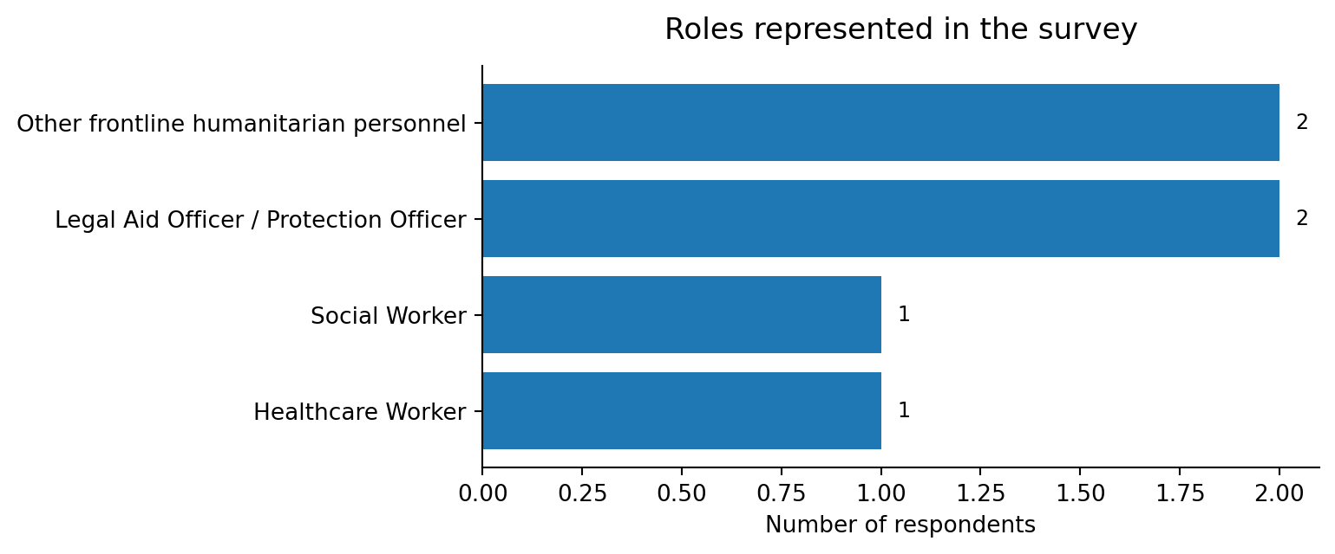
Figure 1. Roles represented in the service-provider sample.
Source: KoboToolbox Service Provider Survey, updated export dated 1 August 2026 (n = 6).
The sample covered several frontline functions but remained concentrated in legal/protection and other humanitarian roles. Four respondents worked outside Bidibidi in other refugee-hosting areas, although the specific locations were not recorded in the exported responses. This limits location-specific comparison.

3.2 General communication challenges (RQ1)
Language-discordant contact was routine. Three respondents reported that they always interacted with clients whose primary language differed from theirs, one reported often, and two reported sometimes. Therefore, four of six respondents encountered such interactions often or always.
Language used to deliver services | Count | Percent
English | 5 | 83.3%
Kiswahili | 5 | 83.3%
Other languages | 3 | 50.0%
Acholi | 1 | 16.7%
Kinyarwanda | 1 | 16.7%
Source: Harmonised select-multiple responses; percentages may exceed 100%.
English and Kiswahili were the most commonly used service-delivery languages, each selected by five respondents. Three respondents selected other languages, while Acholi and Kinyarwanda were each reported once. Refugee clients were reported to speak several languages not fully captured in the fixed response list. Five respondents selected “Other” for client languages, with free-text examples including Kinyabwisha and Kiswahili; one respondent also selected Juba Arabic and Zande.
Support gaps were similarly diverse. Three respondents selected “Other” as a language for which interpretation or translation support was difficult to obtain, two selected English, and one reported that support was adequate for all languages encountered. One free-text response specifically identified Kinyabwisha as difficult to support.
Professional interpreter availability | Count | Percent
Never available | 2 | 33.3%
Rarely available | 1 | 16.7%
Sometimes available | 2 | 33.3%
Always available | 1 | 16.7%
Source: KoboToolbox Service Provider Survey, updated export dated 1 August 2026 (n = 6).
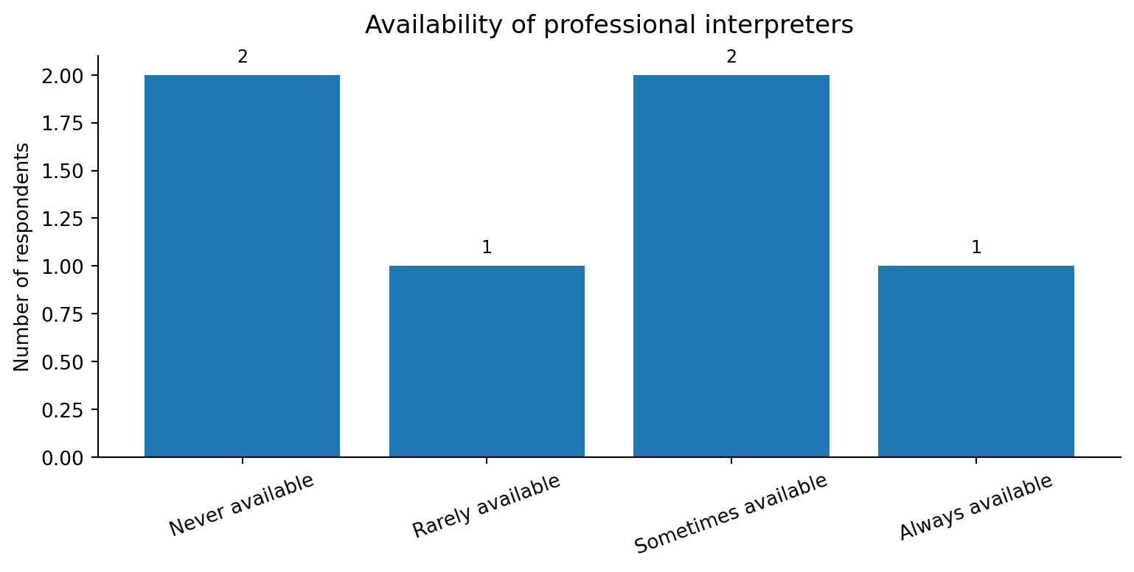
Figure 2. Reported availability of professional interpreters.
Source: KoboToolbox Service Provider Survey, updated export dated 1 August 2026 (n = 6).
Professional interpreter access was uneven. Three respondents rated interpreters as never or rarely available, two as sometimes available, and one as always available. At the same time, every respondent reported relying on informal interpreters at least sometimes: three sometimes, two frequently, and one always. This suggests that informal interpretation is a routine operational response rather than an exceptional measure.
Concerns about informal interpreters were evenly divided. Three respondents identified accuracy of translation as their biggest concern, and three identified confidentiality. Overall communication effectiveness also varied: three respondents considered their communication somewhat effective, one was neutral, one considered it somewhat ineffective, and one considered it very ineffective.

3.3 Health-service delivery (RQ2)
Very limited evidence base
Only one healthcare worker responded to the health-specific questions. The following findings describe that individual response and must not be interpreted as representative of health services.

Health-specific issue | Response of healthcare respondent
Understanding of consent information | Fairly confident
Confidentiality affecting interpreter choice | Sometimes
Clients delaying/avoiding services | Rarely
Preventive health messaging affected | Rarely
Language barrier contributing to clinical error or missed diagnosis | Sometimes
Source: Health-specific skip-logic questions; valid n = 1.
The healthcare respondent was fairly confident that patients understood consent information when a language barrier was present. However, the respondent also indicated that language barriers sometimes contributed to a clinical error or missed diagnosis. Confidentiality sometimes affected interpreter choice, while delays in seeking services and difficulties delivering preventive health messages were reported as rare. The question on accurately understanding symptoms or medical history did not contain an analysable response in the export.

3.4 Legal and protection-service delivery (RQ3)
Very limited evidence base
Two legal aid/protection officers responded to the legal-specific questions. Results show contrasting individual experiences and cannot be generalised to legal or protection services.

Legal-specific issue | Respondent A | Respondent B
Accurately recording statements or case details | Sometimes | Always
Confidence that clients understand rights and procedures | Somewhat confident | Completely confident
Clients delaying/avoiding services because of expected language barriers | Sometimes | Always
Language barriers contributing to incomplete or inaccurate case records | Sometimes | Always
Source: Legal-specific skip-logic questions; valid n = 2.
Both legal respondents reported that language barriers affected core service processes, although the frequency differed. One reported “sometimes” and the other “always” for difficulties accurately recording statements, client delay or avoidance, and incomplete or inaccurate case records. Confidence that clients understood legal rights and procedures ranged from somewhat confident to completely confident. These individual responses indicate issues that deserve further investigation with a larger legal-service sample.

3.5 Communication strategies and tools used (RQ4)
Bilingual staff emerged as the strongest current strategy. Four respondents used bilingual staff often or always, producing the highest mean frequency score (2.83 out of 4) and the highest mean reliability score (3.83 out of 5). Professional interpreters were used less frequently, consistent with reported availability constraints, but received a moderate mean reliability score of 3.00.
Strategy | Mean use  (0–4) | Often/always  count | Mean reliability  (1–5)
Bilingual staff | 2.83 | 4 | 3.83
Professional interpreter | 1.83 | 2 | 3.00
Family/community member | 1.33 | 0 | 1.67
Other | 1.17 | 0 | 3.00
Translation app | 0.83 | 1 | 2.17
Printed multilingual materials | 0.67 | 0 | 1.83
Source: KoboToolbox Service Provider Survey, updated export dated 1 August 2026 (n = 6).
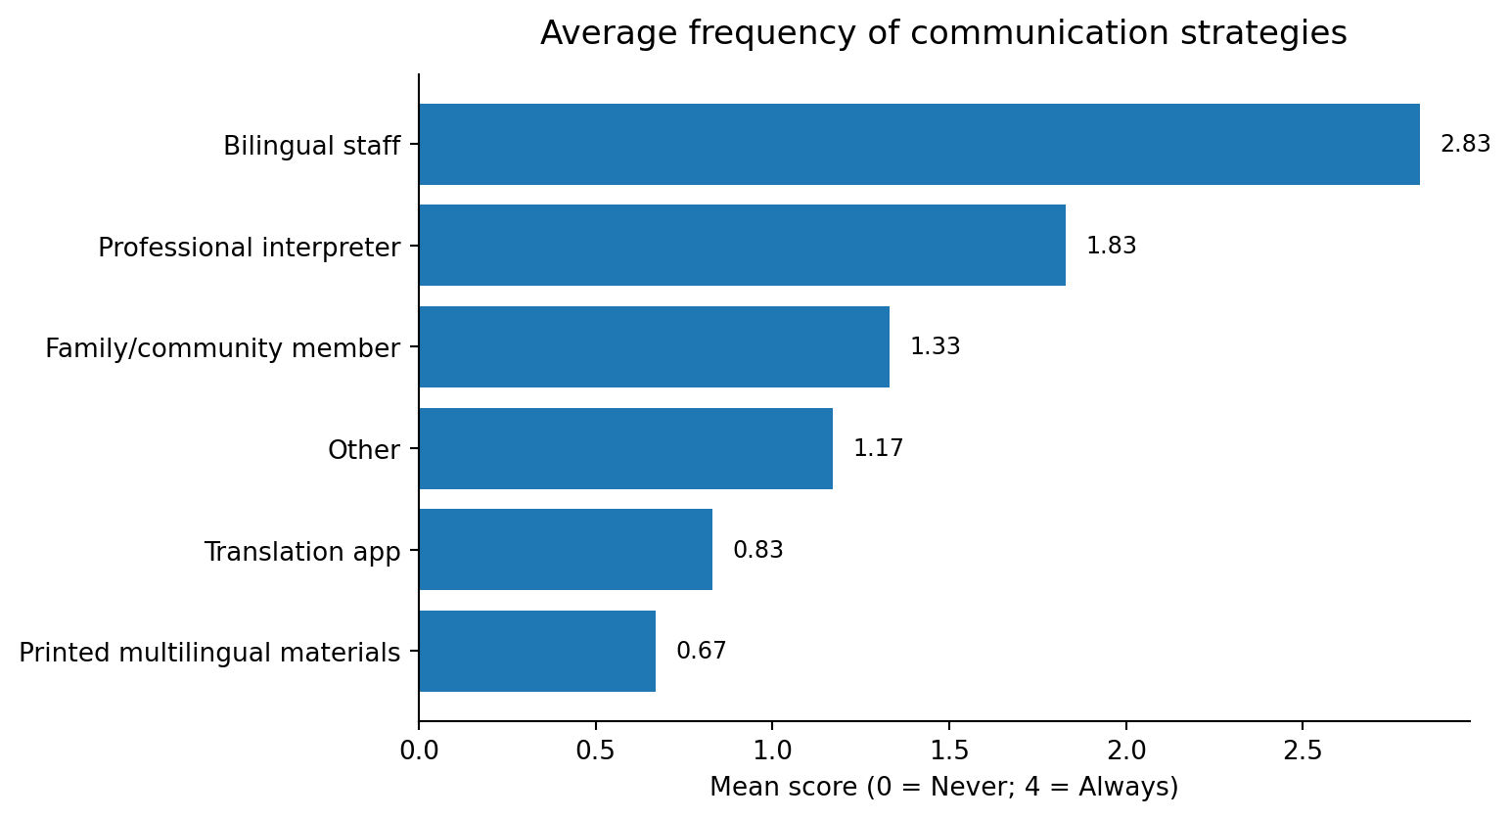
Figure 3. Average frequency of communication strategies.
Source: KoboToolbox Service Provider Survey, updated export dated 1 August 2026 (n = 6).
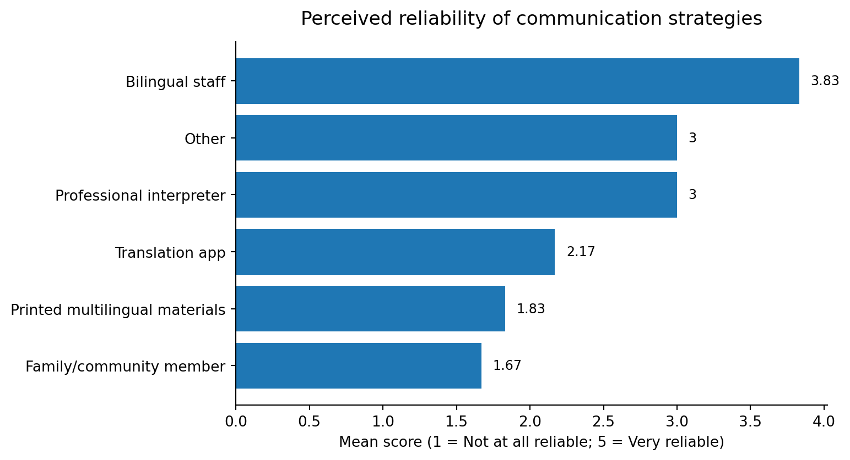
Figure 4. Average perceived reliability of communication strategies.
Source: KoboToolbox Service Provider Survey, updated export dated 1 August 2026 (n = 6).
Translation apps and printed multilingual materials were used relatively infrequently. Translation apps had a mean frequency score of 0.83 and a mean reliability score of 2.17. Printed materials had the lowest mean frequency score (0.67), while family or community members had the lowest mean reliability score (1.67). These findings support the concern that readily available informal options may not be considered sufficiently accurate or dependable for sensitive service delivery.

3.6 Digital readiness and structural barriers
Most respondents had access to a digital device: four used an employer-provided device and one used a personal device. One respondent had no reliable device access. Internet connectivity was described as reliable most of the time by three respondents and reliable sometimes by three. Despite this basic access, digital-tool use was constrained by infrastructure, language coverage, and skills.
Barrier | Count | Percent
Poor connectivity | 4 | 66.7%
Tool doesn't support local languages | 4 | 66.7%
Lack of training | 3 | 50.0%
Limited device access | 2 | 33.3%
Not applicable, I don't use digital tools | 1 | 16.7%
Source: Select-multiple question; percentages may exceed 100%.
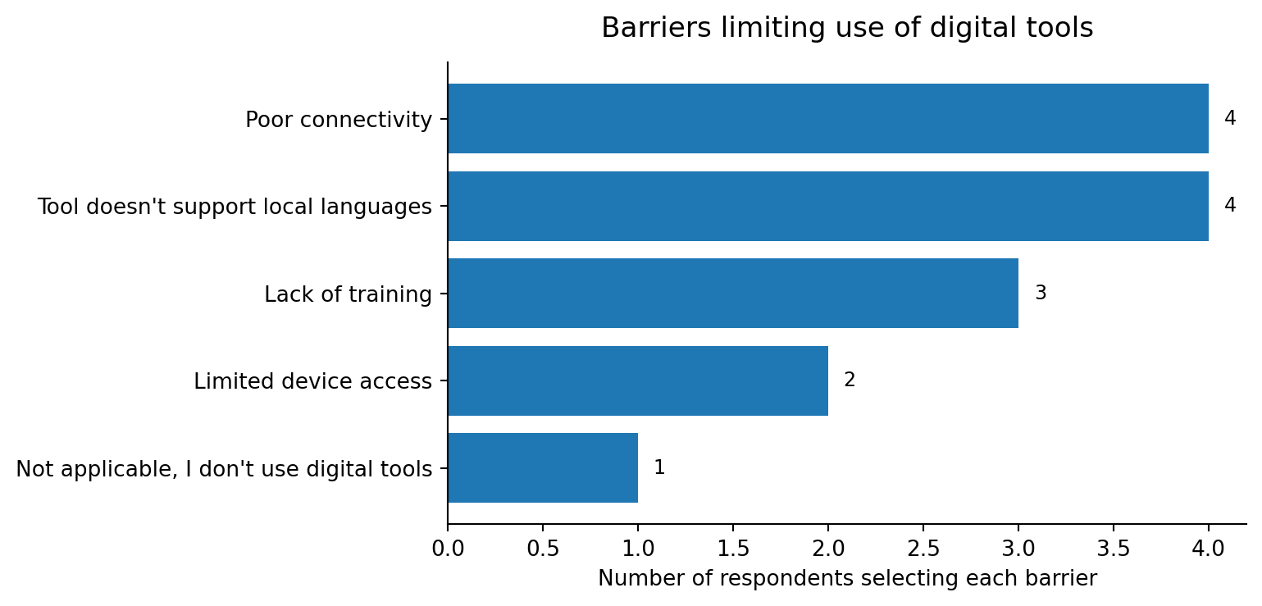
Figure 5. Barriers limiting the use of digital tools.
Source: KoboToolbox Service Provider Survey, updated export dated 1 August 2026 (n = 6).
Poor connectivity and lack of support for local languages were the two most common digital barriers, each selected by four respondents. Lack of training was selected by three, limited device access by two, and one respondent stated that they did not use digital tools. Correspondingly, the most common requested supports were staff training and better internet access, each selected by four respondents. Three requested tools supporting local languages and three requested clear rules on privacy and consent.
Support needed | Count | Percent
Staff training | 4 | 66.7%
Better internet access | 4 | 66.7%
Tools that support local languages | 3 | 50.0%
Clear rules on privacy and consent | 3 | 50.0%
Employer-provided phones/tablets | 2 | 33.3%
Technical support | 2 | 33.3%
Source: Select-multiple question; percentages may exceed 100%.
Trust in machine translation was mixed: two respondents trusted it slightly, two moderately, one not at all, and one very much. Preferences for a future tool were divided equally: two selected an AI chatbot for common phrases or instructions, two selected a mobile app for real-time translation, and two preferred human interpreters rather than a digital tool. Nevertheless, five of six respondents were willing to pilot a new tool if it were provided at no cost. This combination suggests openness to experimentation, but not consensus that technology should replace human interpretation.

3.7 Training, institutional support, and priority needs
Four respondents had not received formal training on working with language-discordant clients, while two had. Perceptions of institutional support were evenly distributed: two rated it very poor, two fair, and two good. The lack of a consistently positive assessment indicates that support differs substantially across workplaces.
Priority | Mentions | First choices | Weighted score
More professional interpreters | 3 | 3 | 9
Formal training | 4 | 1 | 7
Better translation technology | 3 | 1 | 6
More bilingual staff | 3 | 1 | 6
Other | 3 | 0 | 5
Clearer referral protocols | 2 | 0 | 3
Weighting: first choice = 3 points; second = 2; third = 1.
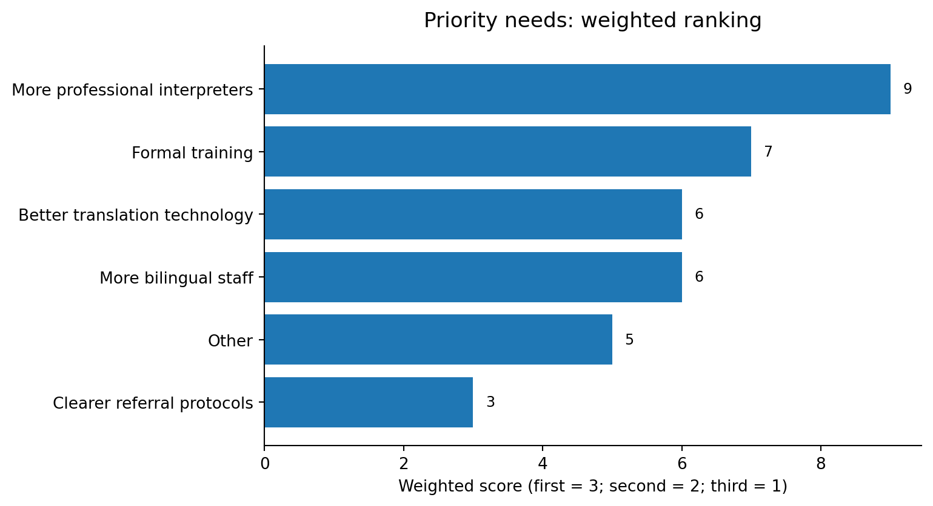
Figure 6. Weighted ranking of service-improvement priorities.
Source: KoboToolbox Service Provider Survey, updated export dated 1 August 2026 (n = 6).
More professional interpreters was the first choice of three respondents and achieved the highest weighted score of 9. Formal training was mentioned by four respondents across the top three rankings and placed second overall with a score of 7. Better translation technology and more bilingual staff each scored 6. These rankings reinforce the need for a combined human-resource, training, and technology response.

4. Discussion
The preliminary findings point to a practical mismatch between the frequency of language-discordant encounters and the availability of professional language support. All respondents encountered clients who spoke a different primary language, yet half rated professional interpreters as never or rarely available. Informal interpreters therefore filled an operational gap, even though respondents were concerned about both accuracy and confidentiality.
Bilingual staff appear to be the most workable existing resource. They were used most frequently and rated most reliable. However, this result should not be interpreted as evidence that bilingual staff can replace trained professional interpreters in sensitive clinical, legal, consent, or protection contexts. The sector-specific responses, although based on very small numbers, included concerns about clinical errors, inaccurate legal records, and delayed access to services.
The data also suggest that technology is most likely to be accepted as a supporting tool. Five respondents were open to a pilot, but two explicitly preferred human interpreters and trust in machine translation ranged from not at all to very. A successful tool would therefore need to be designed for low-bandwidth environments, support relevant local languages, include privacy and consent safeguards, and clearly define when a human interpreter is required.
Training and institutional systems are central. Four respondents had received no formal training, and institutional support was inconsistent. Technology alone would not address the need for interpreter-use protocols, confidentiality standards, referral pathways, and staff capacity to communicate safely and accurately.

5. Preliminary Recommendations
The following recommendations are derived from the survey findings and should be refined after additional service-provider and refugee responses are collected.
- Expand access to professional interpreters. Develop or strengthen interpreter rosters, referral arrangements, and rapid-access mechanisms, prioritising sensitive health, legal, protection, consent, and confidentiality-related interactions.
- Strengthen bilingual staffing without treating it as a complete substitute. Map staff language capacity, recruit bilingual personnel where possible, and define the limits of informal in-house interpretation for high-risk cases.
- Provide formal training and practical protocols. Train staff on working with interpreters, checking understanding, informed consent, confidentiality, documentation, and safe use of digital translation tools.
- Pilot technology as a complement to human support. Test a small, no-cost pilot focused on common phrases or real-time assistance, while maintaining clear escalation to professional human interpreters for sensitive or complex communication.
- Design for local-language and low-connectivity conditions. Prioritise relevant local languages, offline or low-bandwidth functionality, simple interfaces, and employer-supported devices where access remains limited.
- Establish privacy, consent, and accountability rules. Create guidance on data handling, use of personal devices, machine-translation risks, consent, confidentiality, and documentation of translated communication.
- Continue data collection before finalising programme decisions. Recruit a larger and more diverse sample, including more healthcare workers, legal/protection staff, other refugee-hosting areas, and refugees themselves.

6. Limitations
- The sample included only six service providers and was not randomly selected. Results cannot be generalised to all refugee-service providers or refugee-hosting areas.
- Four respondents selected “other refugee-hosting area in Uganda,” but the specific locations were not captured in the exported responses.
- Only one healthcare respondent and two legal/protection respondents completed sector-specific sections. These responses should be treated as individual observations.
- The export contained two form versions. Although duplicate variables were harmonised, version changes and skip logic may have affected question availability and missingness.
- The results are self-reported and were not independently verified through observation, interviews, or administrative service records.
- Refugee perspectives are not included in this report. A complete study report should integrate the refugee survey and compare provider and client experiences.
- The very small sample makes percentages visually large; counts are therefore the primary reporting unit.

7. Conclusion
This preliminary analysis shows that language barriers are a routine feature of service delivery for the six participating providers. Professional interpreter access was inconsistent, informal interpretation was common, and concerns centred on accuracy and confidentiality. Bilingual staff were the strongest existing strategy, while professional interpreters and formal training were the leading priorities for improvement. Respondents were generally open to piloting digital tools, but the data support a human-centred approach in which technology supplements rather than replaces trained language support.
The next phase should expand recruitment, incorporate refugee responses, and use the combined evidence to refine recommendations. Until then, these findings should be presented as exploratory signals that identify practical areas for further investigation and service improvement.

Appendix A. Core Frequency Summary
Indicator | Response | Count | Percent
Interaction with language-discordant clients | Always | 3 | 50.0%
 | Often | 1 | 16.7%
 | Sometimes | 2 | 33.3%
Professional interpreters | Never available | 2 | 33.3%
 | Rarely available | 1 | 16.7%
 | Sometimes available | 2 | 33.3%
 | Always available | 1 | 16.7%
Informal interpreter use | Sometimes | 3 | 50.0%
 | Frequently | 2 | 33.3%
 | Always | 1 | 16.7%
Formal training | No | 4 | 66.7%
 | Yes | 2 | 33.3%
Willing to pilot digital tool | Yes | 5 | 83.3%
 | No | 1 | 16.7%
Source: KoboToolbox Service Provider Survey, updated export dated 1 August 2026 (n = 6).
End of preliminary report

